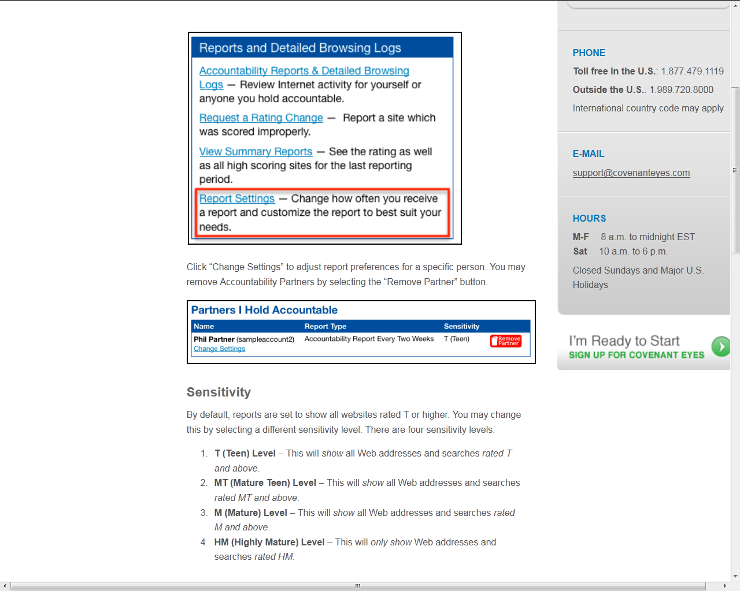

How can I customize my Accountability Report? http://www.covenanteyes.com/support-articles/how-can-i-customize-my-accountability-report/

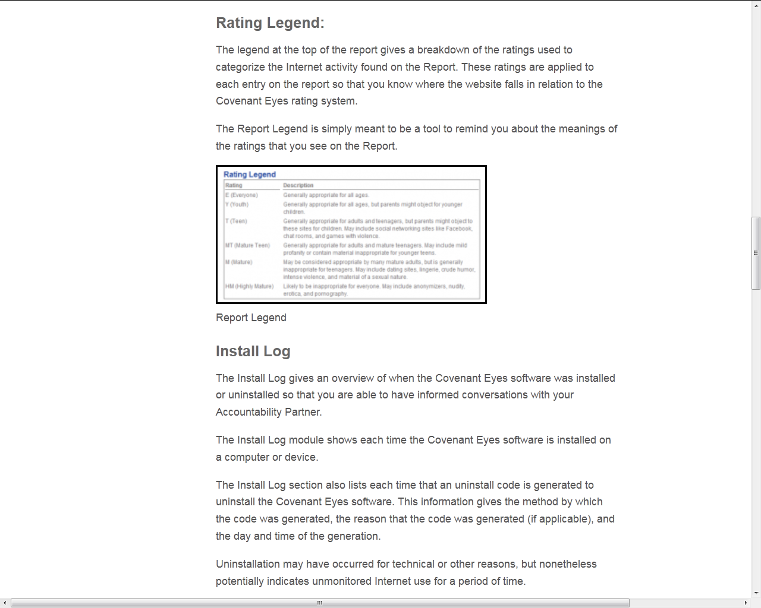

Screen shot from “How do I read the Accountability Report?”
http://www.covenanteyes.com/support-articles/how-do-i-read-the-accountability-report/ This screen shot is continued through page 16.

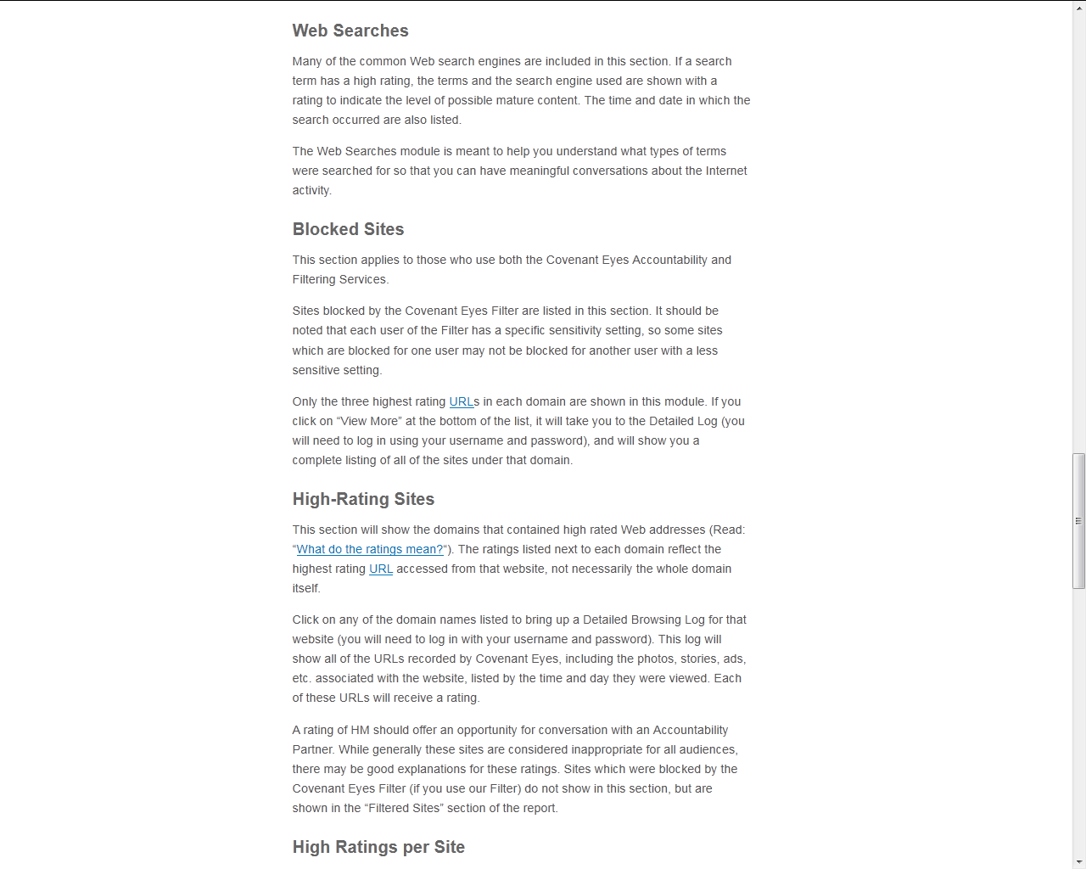

This screen shot is continued from page 13: “How do I read the Accountability Report?”
http://www.covenanteyes.com/support-articles/how-do-i-read-the-accountability-report/

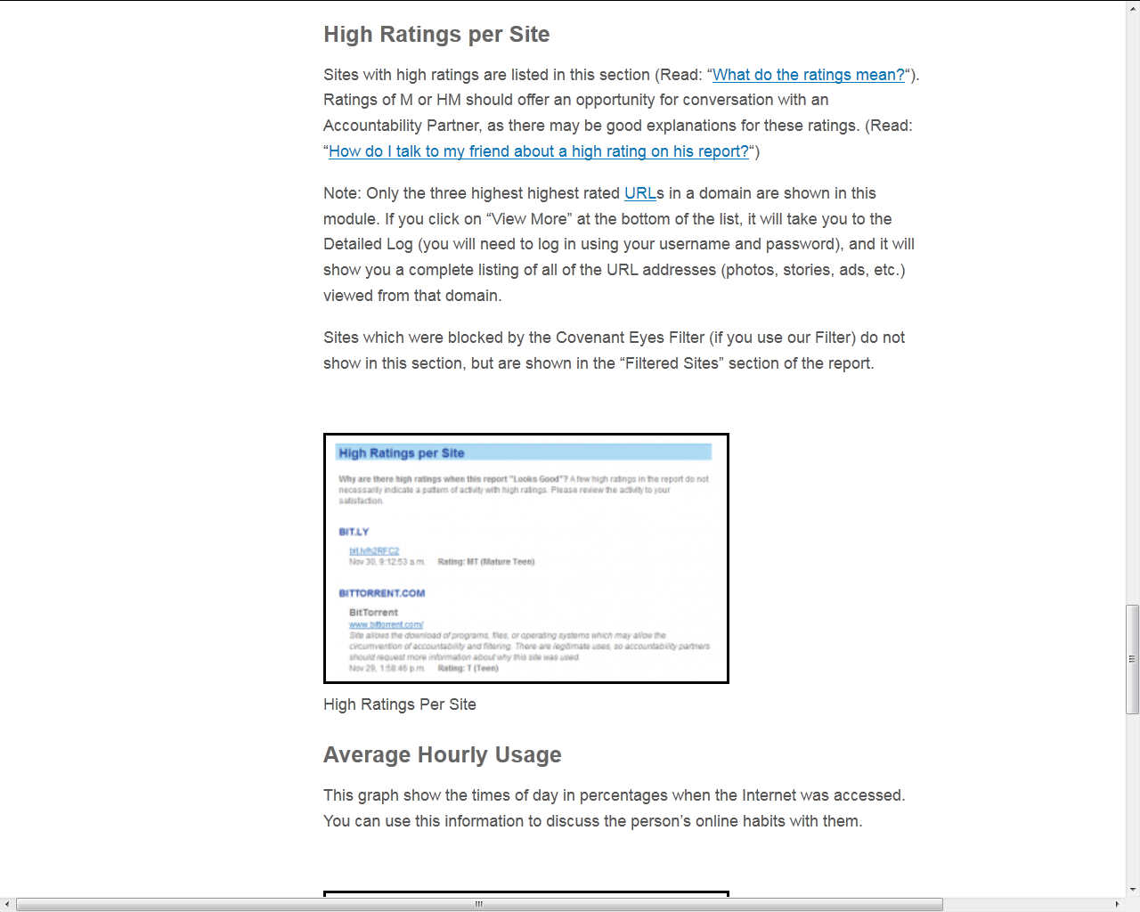

This screen shot is continued from page 14: “How do I read the Accountability Report?”
http://www.covenanteyes.com/support-articles/how-do-i-read-the-accountability-report/

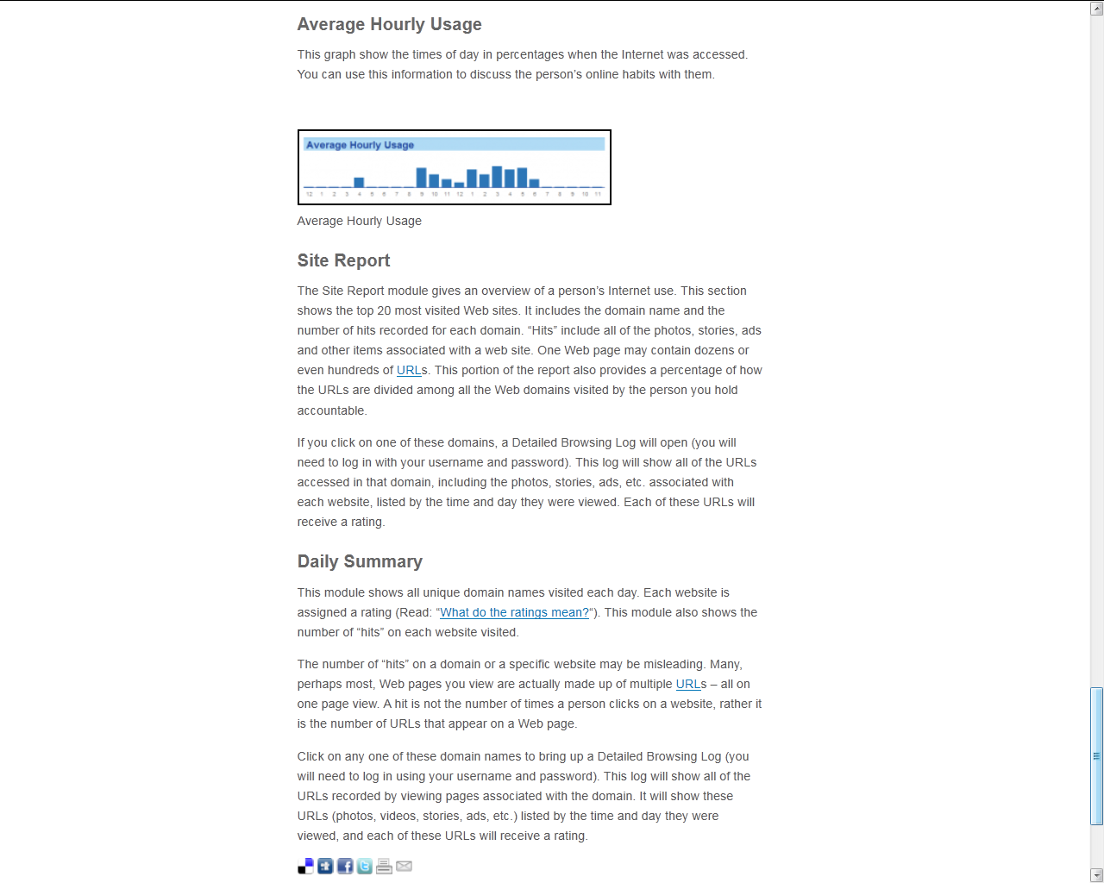

This screen shot is continued from page 15: “How do I read the Accountability Report?”
http://www.covenanteyes.com/support-articles/how-do-i-read-the-accountability-report/

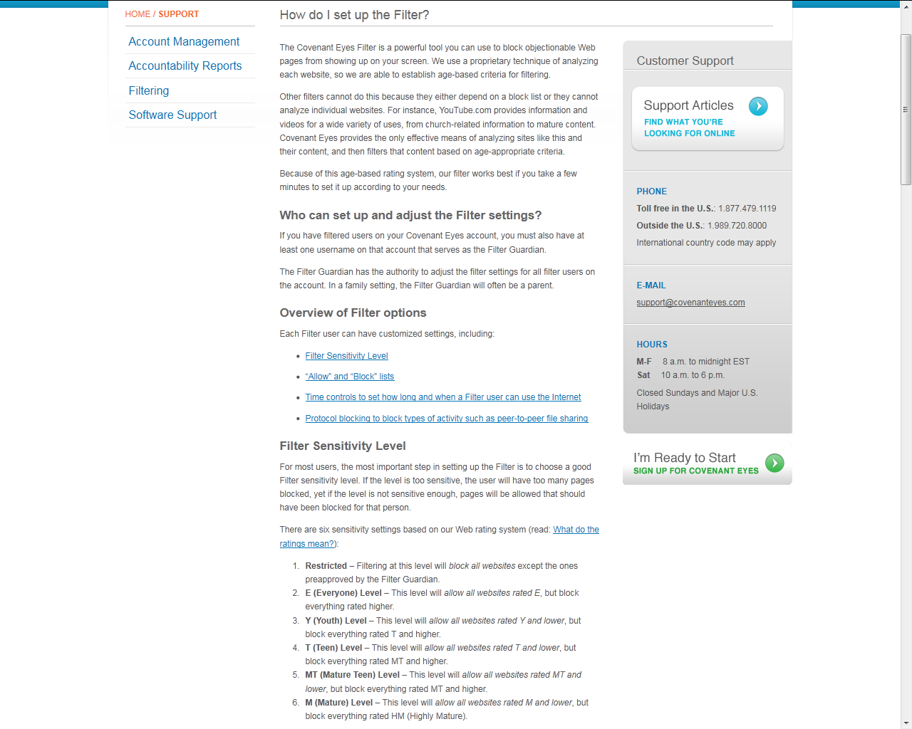

This screen shot from “How do I set up the Filter?” is continued on the next page:
http://www.covenanteyes.com/support-articles/how-do-i-set-up-the-filter/

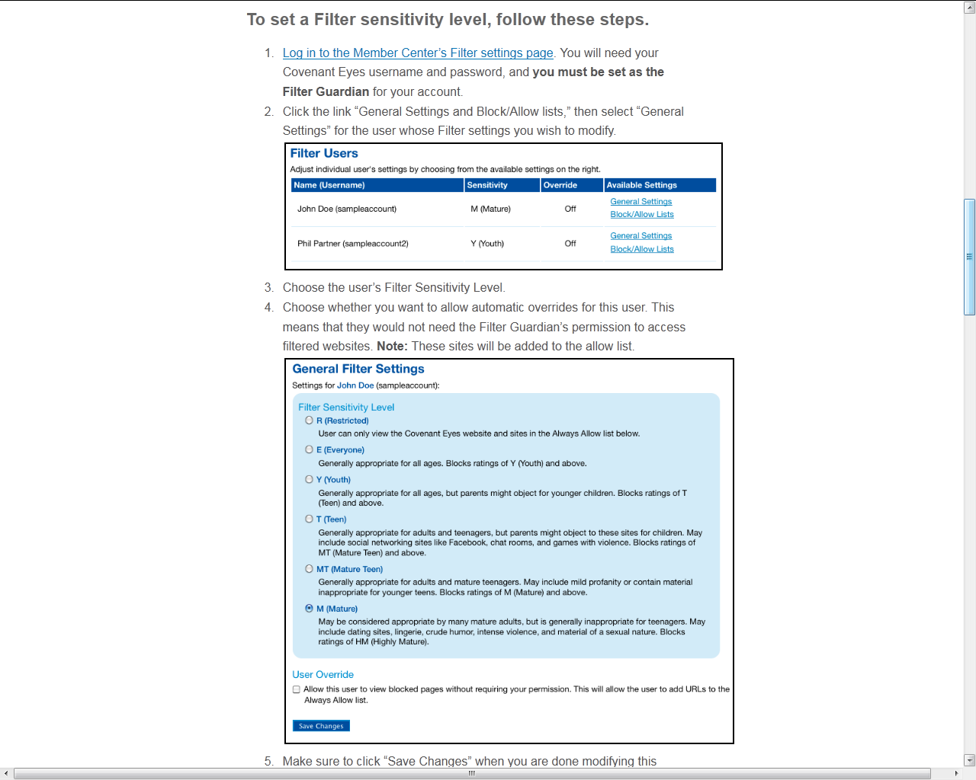

Continued from page 17: “How do I set up the Filter
http://www.covenanteyes.com/support-articles/how-do-i-set-up-the-filter/

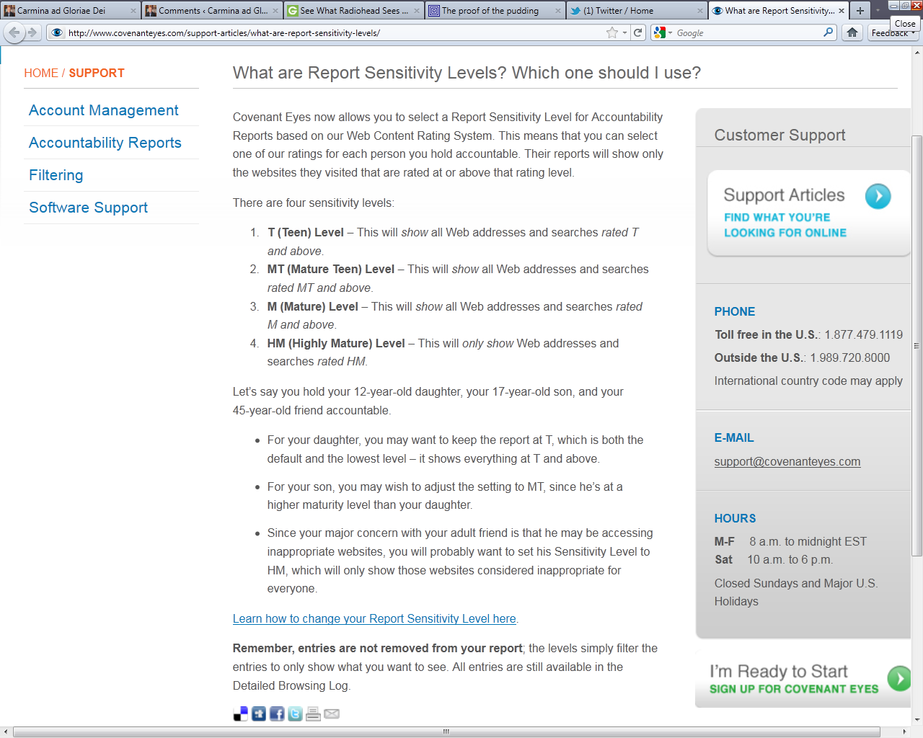

Screen shot from “What are Report Sensitivity Levels? Which one should I use?”
http://www.covenanteyes.com/support-articles/what-are-report-sensitivity-levels/

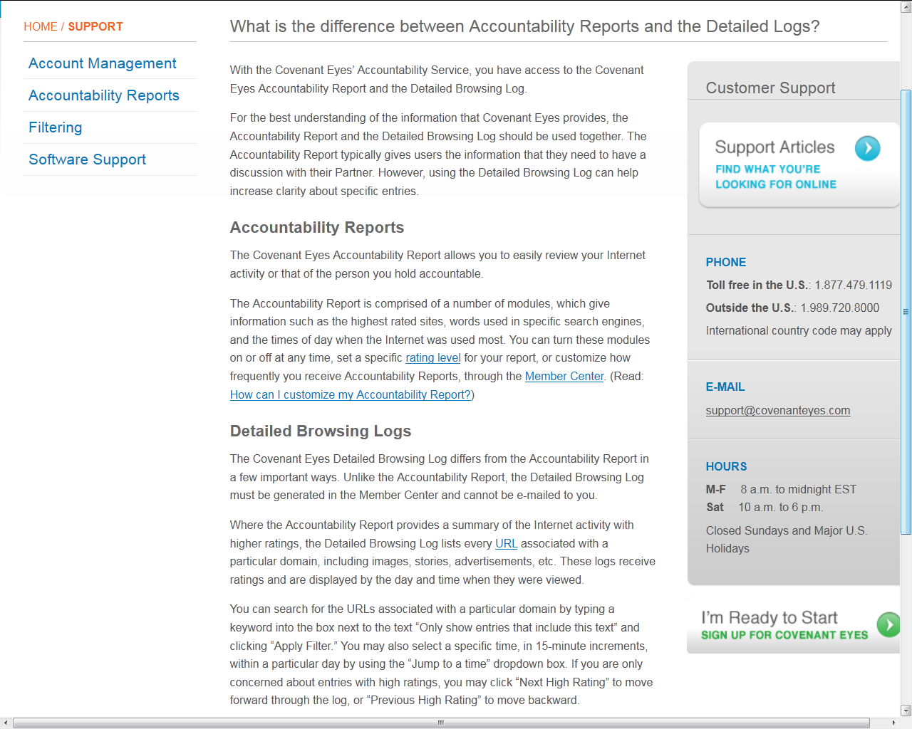

Screen shot from “What’s the difference between Accountability Reports and the Detailed Browsing Log?”
http://www.covenanteyes.com/support-articles/what-is-the-difference-between-accountability-reports-and-the-detailed-logs/

