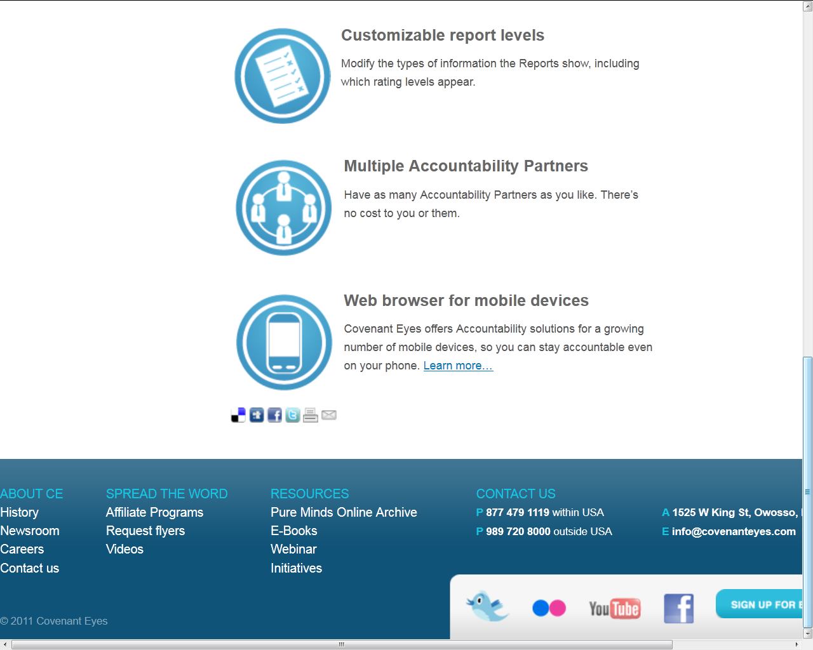

Accountability Features: http://www.covenanteyes.com/services/accountability/feature-tour/
This page will get an additional icon and text. Text is: Customizable Report Levels. Modify the types of information the Reports show, including which rating levels appear.

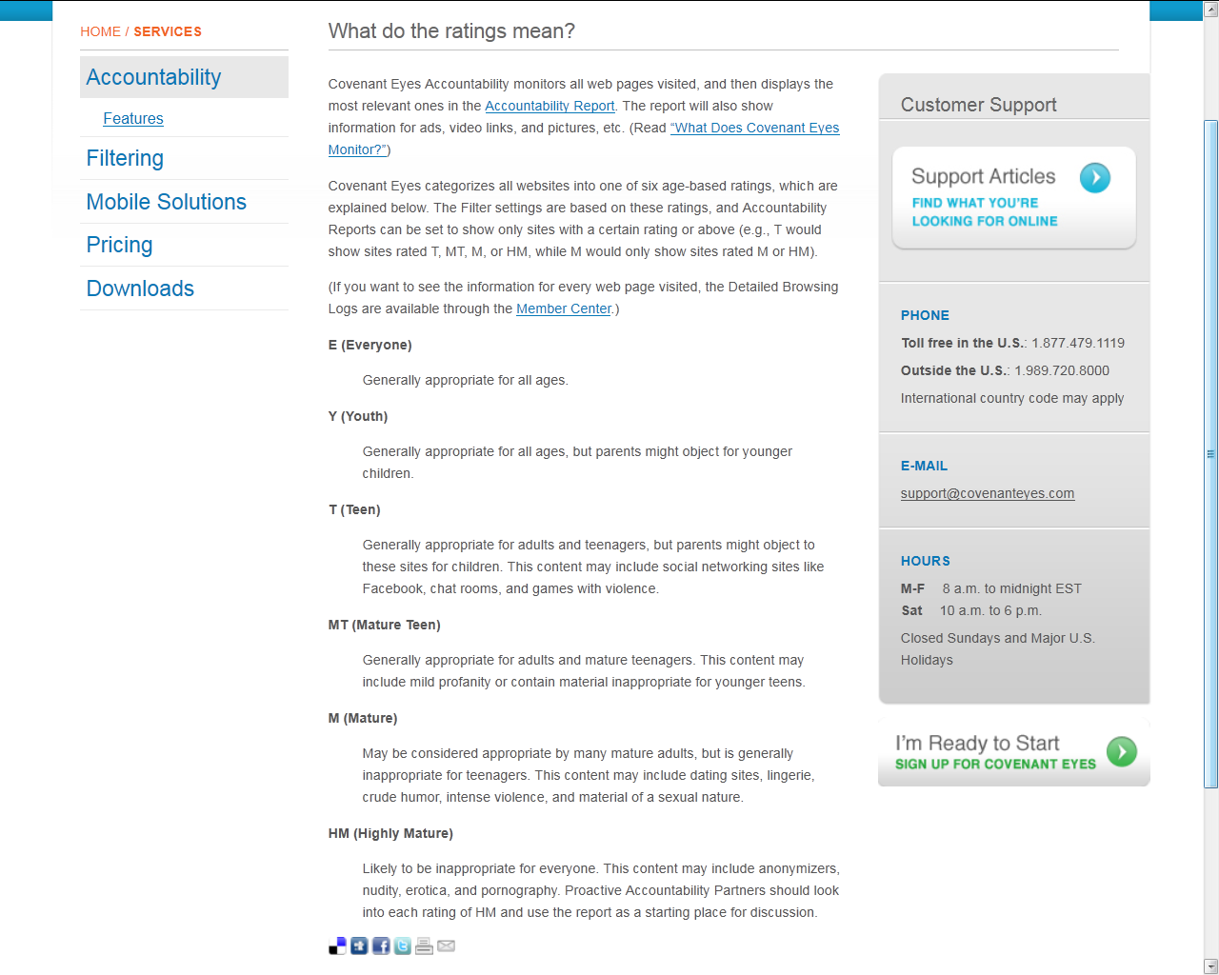
What do the ratings mean?
http://www.covenanteyes.com/services/accountability/feature-tour/what-is-a-score/
This text is updated to explain Report Sensitivity Levels.
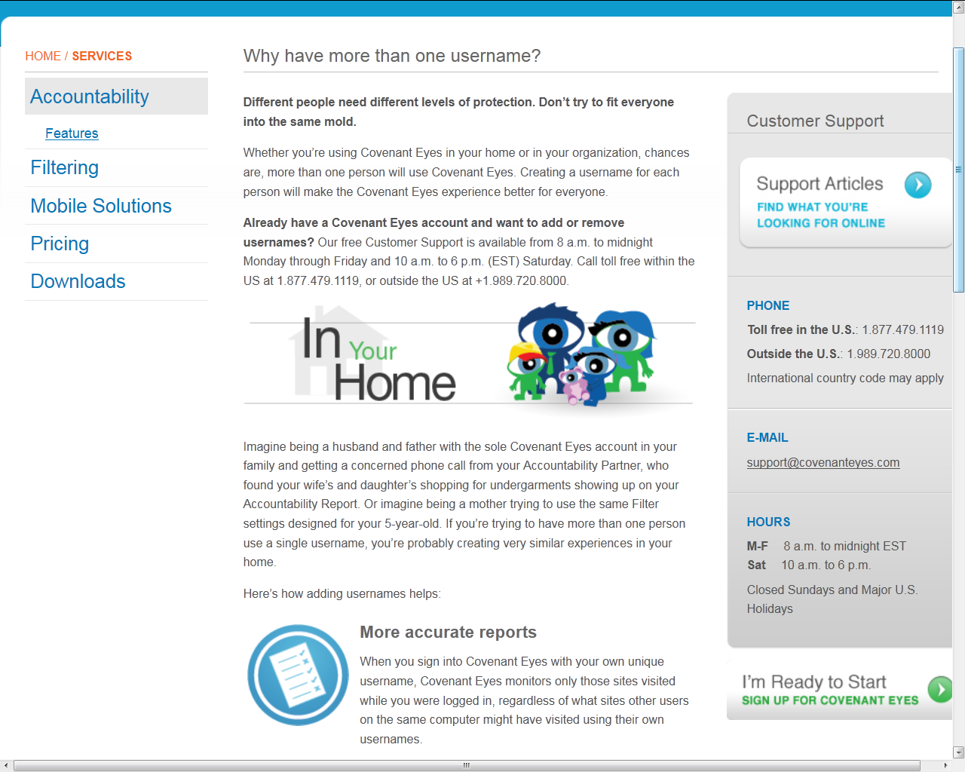
This screen shot is continued on page 4 (below): Why have more than one username?
http://www.covenanteyes.com/services/accountability/feature-tour/why-have-more-than-one-username/ In addition to being redesigned for improved scannability, it incorporates text about RSL.

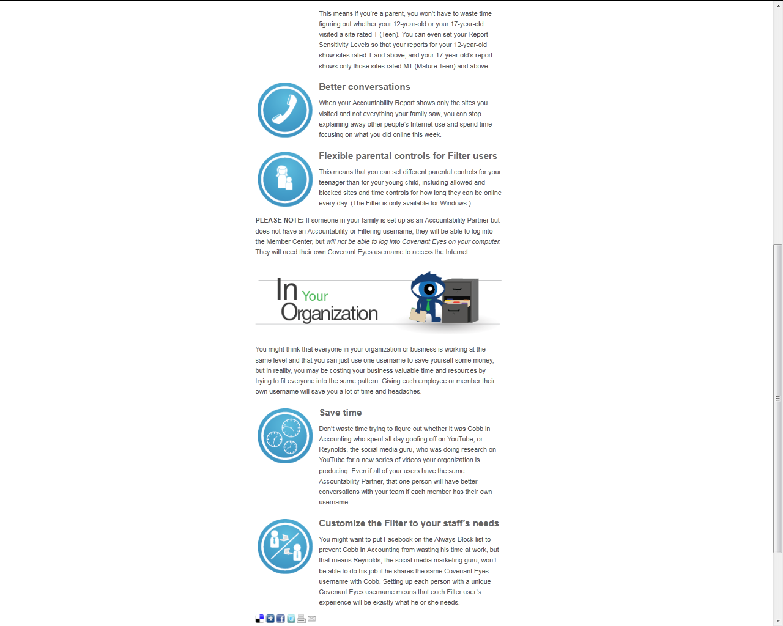
Continued from page 3: Why have more than one username?
http://www.covenanteyes.com/services/accountability/feature-tour/why-have-more-than-one-username/ In addition to being redesigned for improved scannability, it incorporates text about RSL.

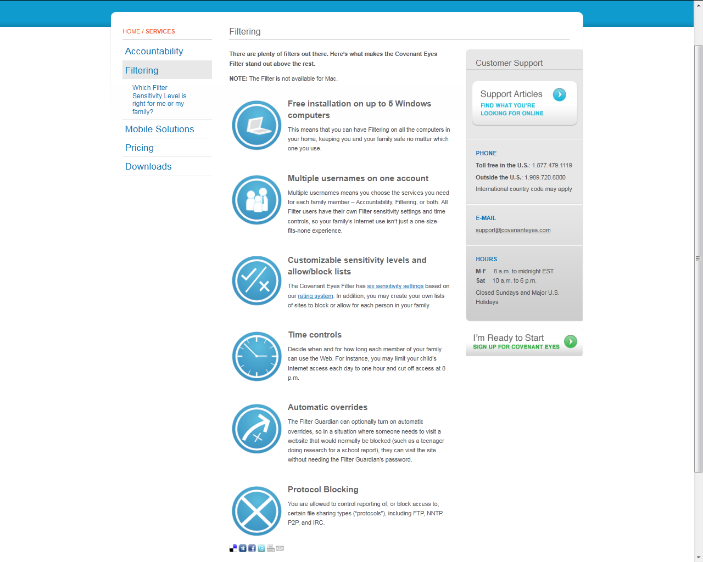

Filtering
http://www.covenanteyes.com/services/filtering/ The page itself only needs small textual changes.

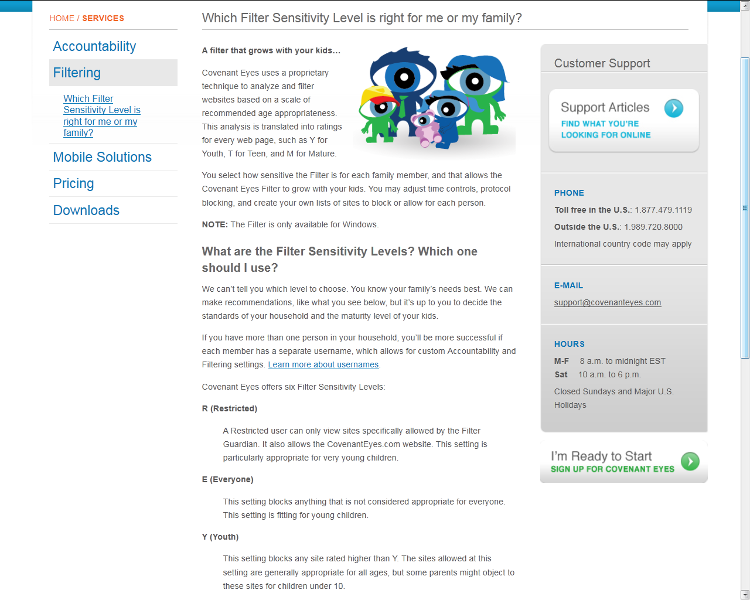

This screen shot is continued on page 7 (below): What Filter Sensitivity Level is right for me or my family? http://www.covenanteyes.com/services/filtering/what-filter-sensitivity-level-is-right-for-me-or-my-family/ This is a brand new sub-page for Filtering, explaining the new Filter levels.

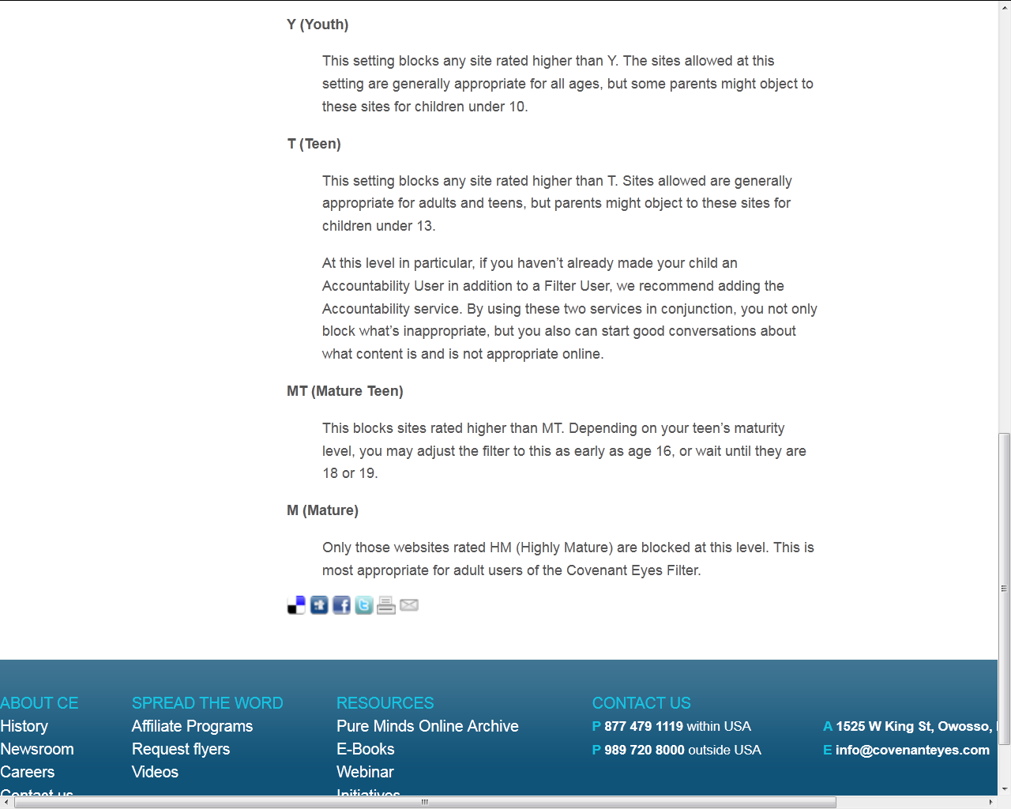

Continued from page 6: What Filter Sensitivity Level is right for me or my family? http://www.covenanteyes.com/services/filtering/what-filter-sensitivity-level-is-right-for-me-or-my-family/ This is a brand new sub-page for Filtering, explaining the new Filter levels.

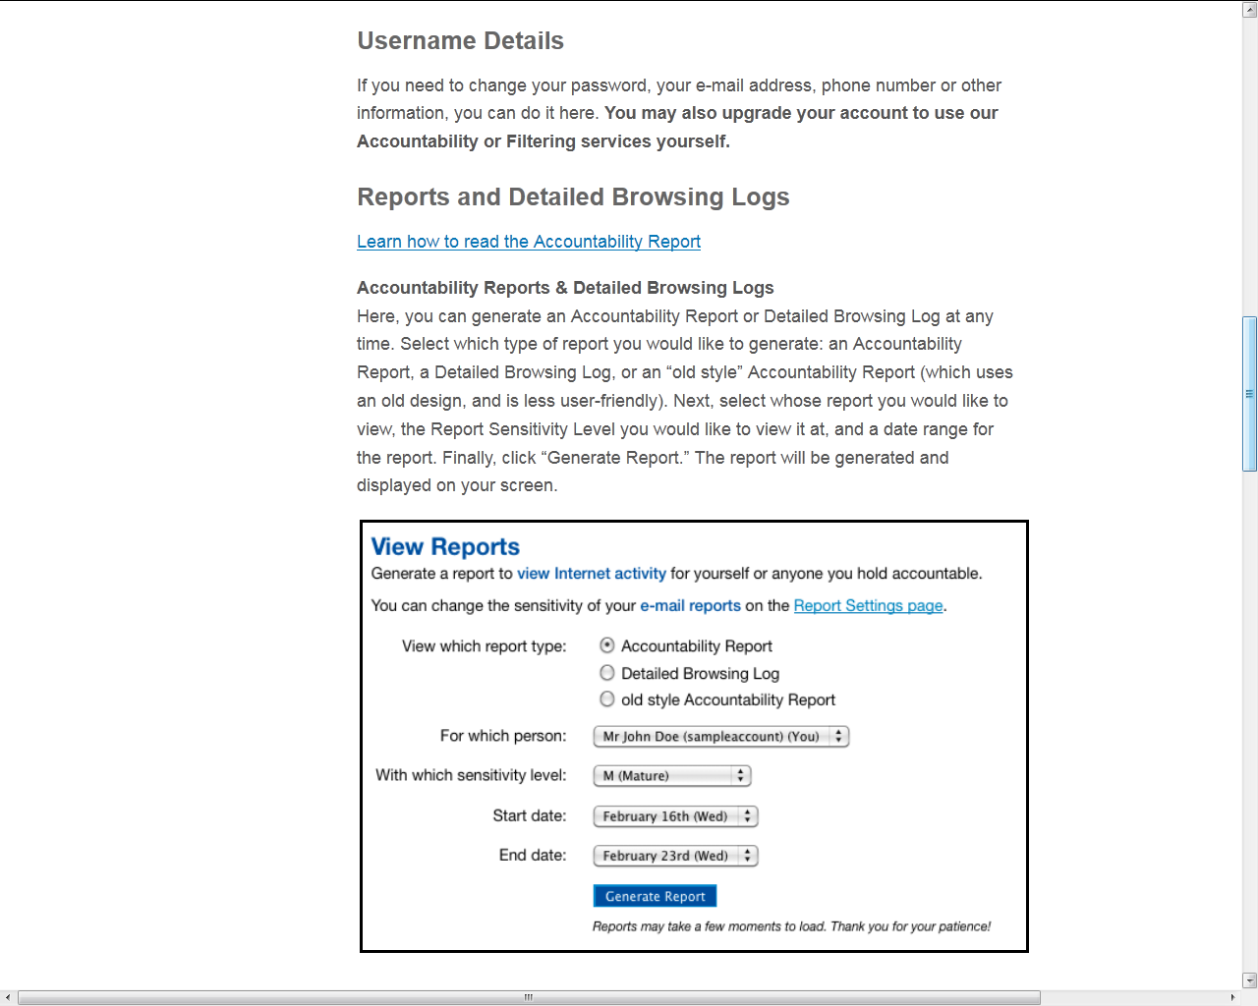

The screenshot of this web page is continued on pages 9 through 11 (below): Tips for Accountability Partners: http://www.covenanteyes.com/services/download/user-manuals/tips-for-accountability-partners/ Information is updated for RSL, and various helpful articles about improving an Accountability relationship are linked.
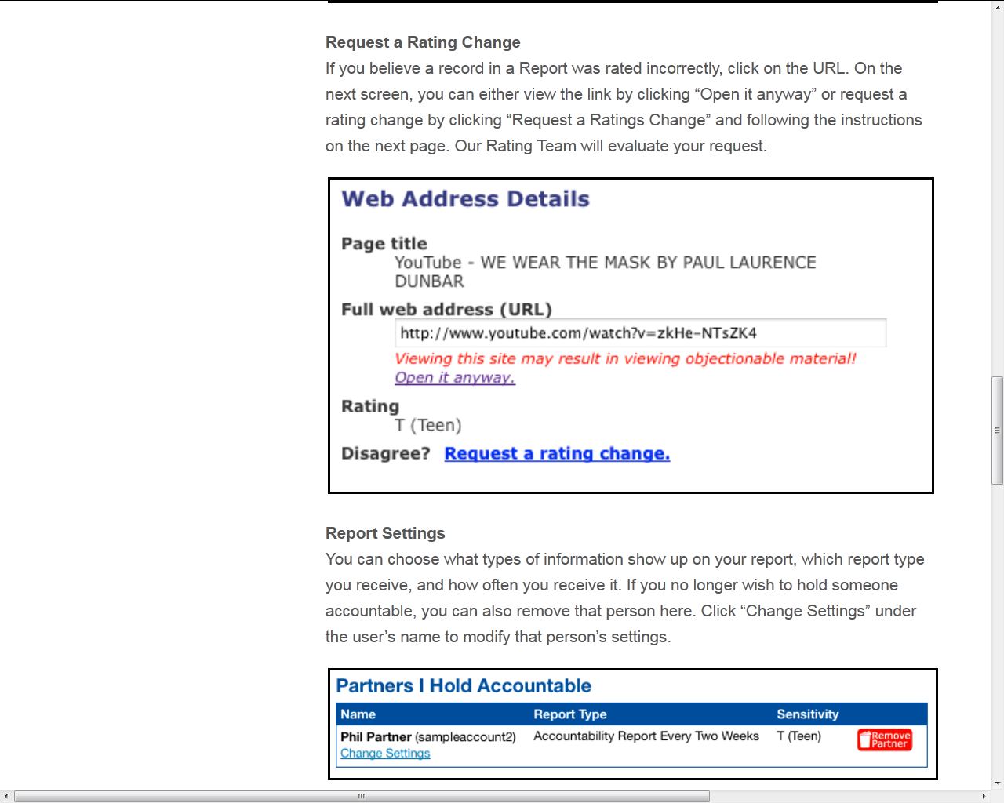

This screenshot is continued from page 8: Tips for Accountability Partners: http://www.covenanteyes.com/services/download/user-manuals/tips-for-accountability-partners/ Information is updated for RSL, and various helpful articles about improving an Accountability relationship are linked.

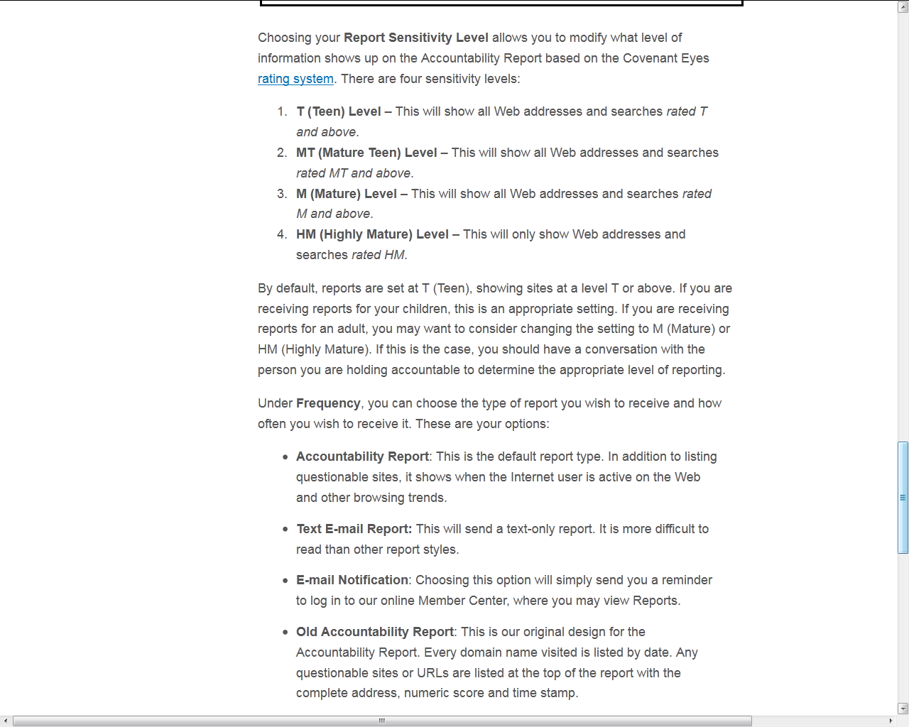

This screenshot is continued from page 9: Tips for Accountability Partners: http://www.covenanteyes.com/services/download/user-manuals/tips-for-accountability-partners/ Information is updated for RSL, and various helpful articles about improving an Accountability relationship are linked.

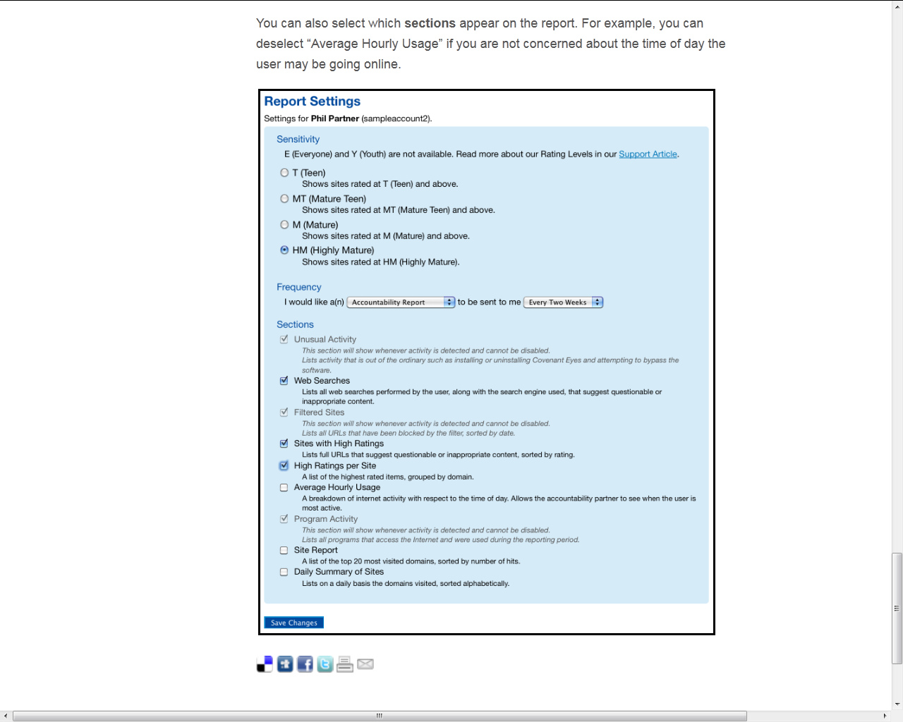
This screenshot is continued from page 10: Tips for Accountability Partners: http://www.covenanteyes.com/services/download/user-manuals/tips-for-accountability-partners/ Information is updated for RSL, and various helpful articles about improving an Accountability relationship are linked.

